from Book 22: The Death of Hektor
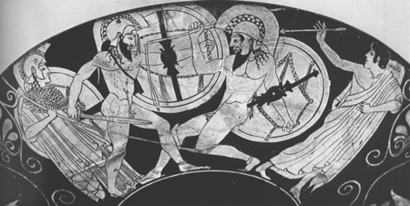
Note: After killing Patroclus, Hektor strips Patroclus’ body of Achilles’ armor before giving the body back to the Greeks for burial. When Hektor faces Achilles, he is wearing Achilles’ armor.
Questions for pages 246-252
- What effect do you think the sight of the enemy wearing his own armor might have on Achilles?
- How does the opening scene between Achilles and Apollo prove that even the greatest heroes are no match for the gods? (1-25)
- Homer uses an epic simile to compare Achilles to a star in the constellation Orion, named after the hunter. What other imagery in this section uses hunting imagery? (1-25)
- Who is Achilles’ really “quarry”?
- What qualities of Achilles are captured in this comparison? (30-37)
- What is Priam’s opinion of Achilles? (43-69)
- What is Priam’s vision of his own death? (78-84)
- Why does the death of a young warrior distress Priam less than the death of old people? (84-91)
- What does Hecuba say will happen if Hektor fights Achilles? (100-108)
- To what is Hektor compared in lines (112-116)
- Before Hektor and Achilles fight, there is a scene of deliberation, in which Hektor weighs the decision before him. Why does Hektor refuse to back down? How does he convince himself to fight Achillles? (120-156)
- To what are Achilles and Hektor compared in lines 167-174? How are these epic similes appropriate?
- How does the comparison of Hektor and Achilles’ fight to that of a chariot race make the scene more vivid? (lines 193-198)

