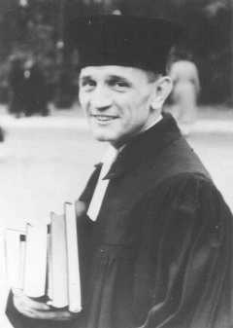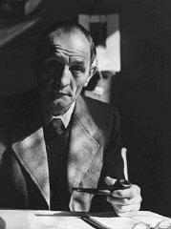
Martin Niemöller (1892–1984) was a prominent Protestant pastor who emerged as an outspoken public foe of Adolf Hitler and spent the last seven years of Nazi rule in concentration camps.
Niemöller is perhaps best remembered for the words:
First they came for the Communists
And I did not speak out
Because I was not a Communist
Then they came for the Socialists
And I did not speak out
Because I was not a Socialist
Then they came for the Jews
And I did not speak out
Because I was not a Jew
Then they came for me
And there was no one left
To speak out for me.

Quickwrite: Is silence violence? If you see something that is wrong or terrible happening to another person, what is your responsibility? If you see an attack, and say or do nothing, are you as guilty as the attacker? If you see someone being bullied, and say or do nothing, are you a bully too?

