The Epic of Gilgamesh (138-151)
Epic hero—epic heroes, unlike some modern day heroes, are exceptional, superior beings. They possess superhuman strength, superior cunning and are often leaders of their people. Epic heroes, while part divine, are also part human—which means they also possess human flaws and weaknesses.
As you read the epic, chart the hero’s quest and pay close attention to the flaws in his character. For what does he seek and does he obtain it?

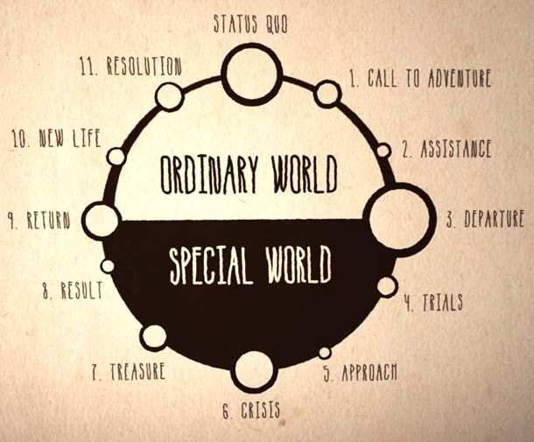
- Describe Gilgamesh’s “ordinary world.” Who is he? What is he like at the start of his journey? _________________________________________________________________________________________________________________________________________________________________________________________________________________________________________________________________________________
- What is his call to action? _________________________________________________________________________________________________________________________________________________________________________________________________________________________________________________________________________________
- From whom does he receive assistance? _________________________________________________________________________________________________________________________________________________________________________________________________________________________________________________________________________________
- Describe the moment that leads Gilgamesh across the threshold into the special/unknown world: _________________________________________________________________________________________________________________________________________________________________________________________________________________________________________________________________________________
- What trials/challenges does he face in the unknown world? _______________________________________________________________________________________________________________________________________________________________________________________________________________________________________________________________________________________________________________________________________________________________________________________________________________________________________________________________________
- Describe the approach and crisis: ____________________________________________________________________________________________________________________________________________________________________________________________________________________________________________________________________________________________________________________________________________________________________________
- Does he find the treasure he seeks? Reap any rewards? ____________________________________________________________________________________________________________________________________________________________________________________________________________________________________________________________________________________________________________________________________________________________________________
- Describe Gilgamesh’s return. What can be said of his new life? How has his ordinary world changed? ____________________________________________________________________________________________________________________________________________________________________________________________________________________________________________________________________________________________________________________________________________________________________________
Final thoughts
- Situational irony is the contrast between what is expected to happen and what actually does. Explain what is ironic about what happens to the plant of eternal youth. What does this irony teach Gilgamesh? ____________________________________________________________________________________________________________________________________________________________________________________________________________________________________________________________________________________________________________________________________________________________________________
- An epic hero in some ways represents the highest values of his culture and acts with his or her people in mind. In what ways is Gilgamesh’s quest selfish? In other ways, how is he undertaking his quest for all the people of Uruk? What does he ultimately bring back to his people? ____________________________________________________________________________________________________________________________________________________________________________________________________________________________________________________________________________________________________________________________________________________________________________

