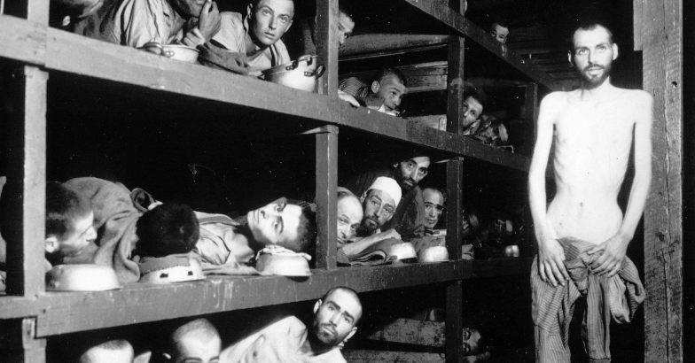“Never shall I forget that night, the first night in camp, which has turned my life into one long night, seven times cursed and seven times sealed....Never shall I forget those moments which murdered my God and my soul and turned my dreams to dust. Never shall I forget these things, even if I am condemned to live as long as God Himself. Never.”
― Elie Wiesel, Night
- “For the survivor who chooses to testify, it is clear: his duty is to bear witness for the dead and for the living. He has no right to deprive future generations of a past that belongs to our collective memory. To forget would be not only dangerous but offensive; to forget the dead would be akin to killing them a second time.”
― Elie Wiesel, Night
How does this quotation compare to Artie’s rationale for writing Maus on page 42?

- “There's a long road of suffering ahead of you. But don't lose courage. You've already escaped the gravest danger: selection. So now, muster your strength, and don't lose heart. We shall all see the day of liberation. Have faith in life. Above all else, have faith. Drive out despair, and you will keep death away from yourselves. Hell is not for eternity. And now, a prayer - or rather, a piece of advice: let there be comradeship among you. We are all brothers, and we are all suffering the same fate. The same smoke floats over all our heads. Help one another. It is the only way to survive.”
― Elie Wiesel, Night
How does this quotation relate to Vladek’s memory on page 28?

- How does Wiesel’s memory of the cattle car journey and the selection process upon arriving at Auschwitz compare to Vladek’s recollection on pages 25-27?

- Pages 69-72 of Maus II explain Vladek’s memory of the gas chambers and crematoriums. How does his memory compare to that of Wiesel’s?

